Quiz 1 ***(CSE331L.7 – Asif Ahmed Neloy_Summer’20)***

Department of Electrical and Computer Engineering

School of Engineering and Physical Sciences

North South University, Bashundhara, Dhaka-1229, Bangladesh

*Time 20 minutes, Marks 20 (You need to answer all questions).*

***Name – SADMAN ALAM***

***ID - 1610544042***

1. **Why it is never a good idea to store any data in the segment registers?[5]**

**Because segment registers have a very special purpose, pointing at accessible blocks of memory. On the other hand segment registers work together with general purpose register to access any memory value. This is why it is never a good idea to store any data in the segment registers.**

1. **Write a program in Assembly language that will add 4 integer number (1,2,2,1) using only AX register and Store the result in the AX register.**

**org 100h**

**MOV AX, 01**

**MOV BX, 02**

**MOV CX, 02**

**MOV DX, 01**

**ADD AX, BX, CX, DX; AX = AX+BX+CX+DX**

**ret**

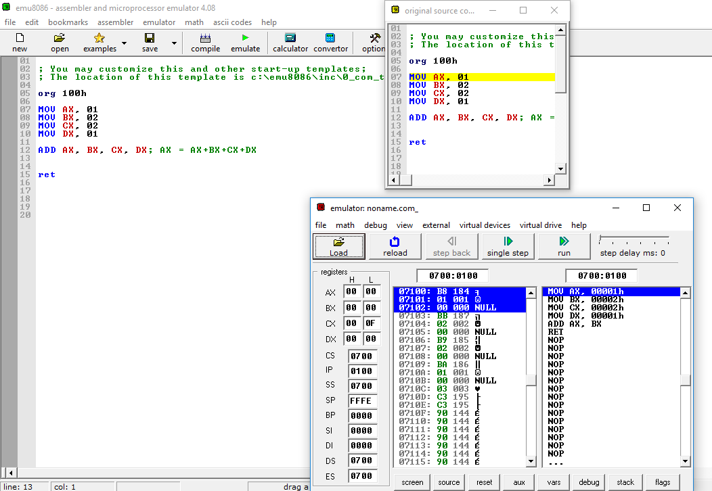

**End**